**Lesson 5 Demo 3**

**Understanding Rolling Updates**



Steps to be followed:

1. Configuring a DaemonSet with rolling update

**Step 1: Configuring DaemonSet with rolling update**

1. Creating a config file with the following command:

**vi *rolupdatedaemon.yaml***



1. Write the following code in the file:

***apiVersion: apps/v1***

***kind: DaemonSet***

***metadata:***

***name: fluentd-elasticsearch***

***namespace: kube-system***

***labels:***

***k8s-app: fluentd-logging***

***spec:***

***selector:***

***matchLabels:***

***name: fluentd-elasticsearch***

***updateStrategy:***

***type: RollingUpdate***

***rollingUpdate:***

***maxUnavailable: 1***

***template:***

***metadata:***

***labels:***

***name: fluentd-elasticsearch***

***spec:***

***containers:***

***- name: fluentd-elasticsearch***

***image: quay.io/fluentd_elasticsearch/fluentd:v2.5.2***

***volumeMounts:***

***- name: varlog***

***mountPath: /var/log***

***- name: varlibdockercontainers***

***mountPath: /var/lib/docker/containers***

***readOnly: true***

***terminationGracePeriodSeconds: 30***

***volumes:***

***- name: varlog***

***hostPath:***

***path: /var/log***

***- name: varlibdockercontainers***

***hostPath:***

***path: /var/lib/***

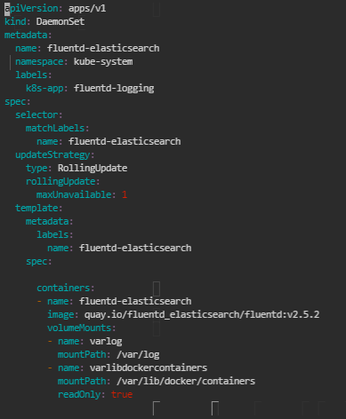

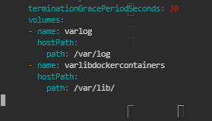

1. Write the following command:

***kubectl apply -f rolupdatedaemon.yaml***



1. Write the following command to check the Daemonset:

***kubectl get ds -A***

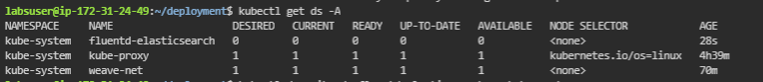

1. Write the following command to describe the DaemonSet:

***kubectl describe ds fluentd-elasticsearch -n kube-system***

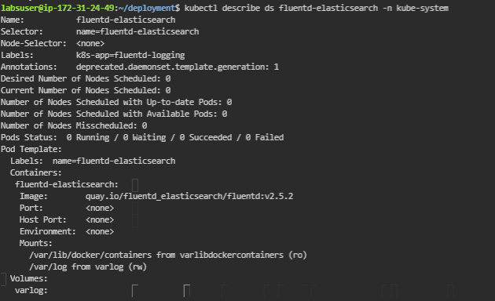

1. Write the following command to check the status:

***kubectl rollout status ds/fluentd-elasticsearch -n kube-system***

